James Moran

This report is a reflection of our team’s development process of the Game Café System. This report details the design, development, testing and reflection of the project, among other aspects.

Development Report

Software Systems Development (AE2)

Contents

List of Tables iii

List of Figures iii

1. Elicitation of Requirements 0

1.1 Work Breakdown Structure (WBS) 1

**1.1.1 Sprint Breakdown** 2

2. Analysis of Requirements 5

2.1 Robustness Diagram 5

2.2 User Stories 6

2.3 Sequence Diagram 7

3. Expression of Requirements 8

4. The Use of SCRUM in Our Team 9

5. Project Design 10

5.1 Structure Chart 10

5.2 Use-Case Diagram 10

6. Project Development 12

Logging my Tasks 12

7. Testing the Project 14

8. Integrating the Project 15

9. Refactoring for the Project 16

10. Configuration Management/Version Control 17

Bibliography 18

References 19

Appendix A: Base Project Requirements 20

Appendix B: User Stories 21

Game Café Staff Member User Stories 21

Game Café Member (Patron) User Stories 21

Appendix C: Requirements Definition A

**Functional Requirements** A

**The user must be able to add new entries to a database** A

**Non-Functional Requirements** B

# List of Tables

**No table of figures entries found.**

# List of Figures

Figure 1: The base Game Cafe Mind Map, based on the requirements noted on the previous page. (Chris Pryor, 2018) 0

Figure 2: Game Cafe Management System WBS. 1

Figure 3: Game Cafe Robustness Diagram for Staff Members. 5

Figure 4: Sequence Diagram for a Staff Member to add information to the management system's database. 7

Figure 5: Structure Chart for adding new entries to the Game Cafe Database. (Chris Pryor, 2018) 10

Figure 6: Use-Case Diagram for Game Cafe Staff Members and Members (patrons) of the Game Cafe. 10

Figure 7: The Basic Class Diagram for the Game Cafe Management System (given the initial set of derived Use-Cases). 11

Figure 8: My Weekly Time-log for the project (the image flows over two pages). 12

# Elicitation of Requirements

For the requirements elicitation (Requirements Gathering), there is the base set of what the User would (most likely), want from the system. This is detailed in Appendix A: Base Project Requirements.

These were obtained from the assignment brief, as this is what the system must have as base requirements.

This was deemed as an appropriate means to get the base set of requirements, as they are noted in the assignment brief and we had no other input to use for the requirements at a base level (such as via surveys, interviews of the client, etc.). Indeed, as interviewing the client would more than likely produce similar results to what is detailed in the assignment brief, for the aspects of such a management system, the Game Café is most likely to want to organise.

From these base requirements, a Mind Map of what the system must have, can be formed. Our project’s Mind Map Is shown below:

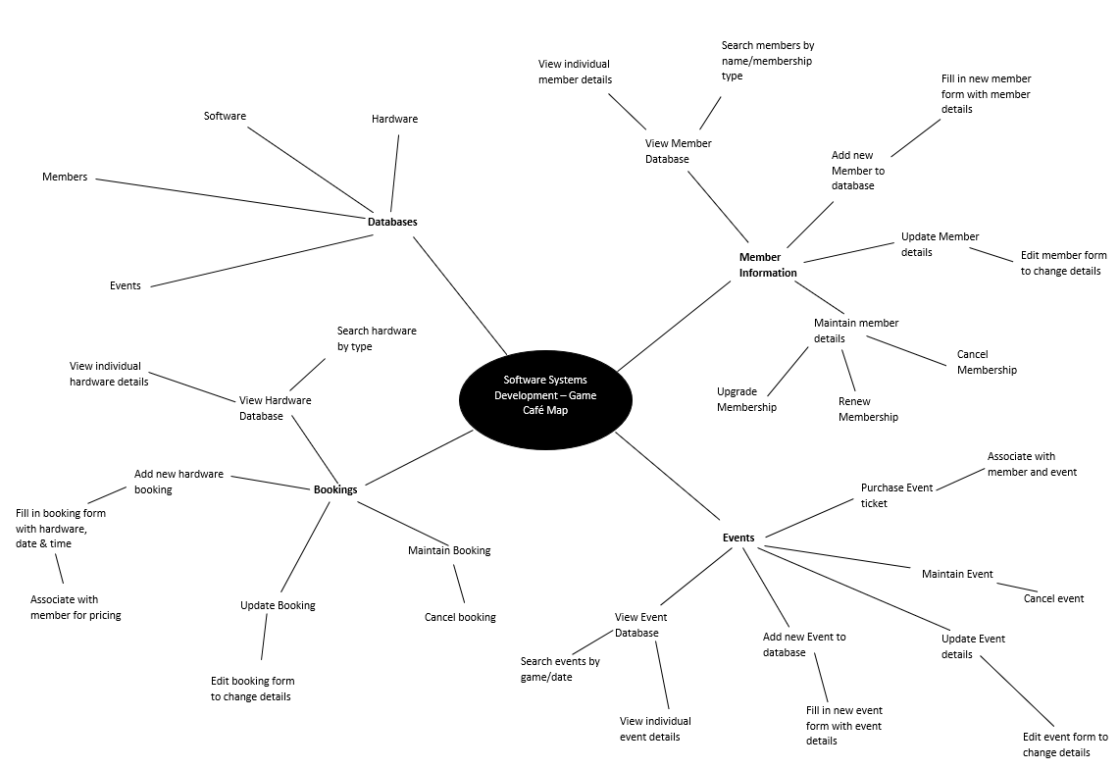Figure 1: The base Game Cafe Mind Map, based on the requirements noted on the previous page. (Chris Pryor, 2018)

From this, a Work Breakdown Structure (WBS) for the project can be formed, this is detailed on the next page.

## 1.1 Work Breakdown Structure (WBS)

Figure 2: Game Cafe Management System WBS.

Project duration: 15 weeks (23/01 – 11/05)

### **1.1.1 Sprint Breakdown**

* Project broken down into 3 sprints
* Sprint duration is 5 weeks per sprint
* Sprint tasks will be broken up into tasks to be accomplished each week
* Team will hold a weekly meeting to discuss progress and establish new targets

#### 1.1.1.1 Sprint 1: 23/01 – 27/02

In this sprint we aim to establish our goals as a group to successfully plan our approach for completing this project. The main target for this sprint is to complete all the planning, analysis and design documents which will allow us to fully flesh out our ideas so that we understand how to build our system and how it will work, ensuring that all requirements are met. We will then work on an initial prototype build so that we have something to show the client at the end of the sprint to show our progress and guarantee the feasibility of the program.

**Sprint Deliverables:** All planning, analysis & design documentation, working prototype which demonstrates feasibility – should be able to ‘access, add to and otherwise manipulate appropriate data within a storage medium of your choice’.

#### 1.1.1.2 Sprint 2: 06/03 – 10/04

This sprint will concentrate on what we have completed successfully as a team and interviewing the customer for further information.

From Sprint 1, we have a basic prototype of the booking system as well as the relevant design documentation.

We have received further instruction from the customer on further requirements to be added, these are:

* As a user, I wish to add a member ‘UnrealDonaldTrump’ to the data stored by the system.  This member is to be registered as an adult with all privileges to play any game on any platform.
* As a user, I wish to add the following platforms to the data stored by the system - ‘Sony PlayStation PS4 Pro’, ‘Microsoft Xbox One X’ each coupled with Acer R240 24-inch Monitor.
* As a user, I wish to add the following games to the data stored by the system - ‘Forza Motorsport 7’ for the Xbox One, PEGI All ‘Gears of War 4’ for Xbox One, PEGI 18, ‘FIFA 18’ for PlayStation 4 and ‘Horizon Zero Dawn’ for PlayStation 4, PEGI 16.  The software should be linked to the platform on which they play.

**Sprint Deliverables:** These requests are trivial and can be added into the database ready to be selected. (Chris Youd, 2018)

#### 1.1.1.3 Sprint 3: 17/04 – 08/05

For this sprint we have had further instruction from the customer to requirements to be added:

* As a user I wish to create a booking for a named adult member who wishes to use a PlayStation 4 to play Far Cry 5 (PEGI 18) on release date (27th March2018) at 16:00 for one hour.
* As a user I wish to create an e-sports event which will be an evening competition featuring Counter Strike: Global Offensive.  The maximum number of participants is four teams of five players.  The date of the event is Friday 27th April.
* As a user I wish to book as a participating team for the event above, the name of the team is StudioCoders.

**Sprint Deliverables:** Adding bookings and events to the system along with teams for events. (Chris Youd, 2018)

This WBS Diagram and respective Sprint Breakdown detail the tasks that we would want to complete for the project, as well as the order for such (left to right in the WBS Diagram and from Sprint 1 to Sprint 3 for the project’s Sprints).

We deemed this as being a suitable method for considering all the work we would have to complete and the respective order for completing these tasks, as is laid out above, because each set of tasks for the phases, must be completed before moving onto the next phase (from the WBS Diagram, for each Sprint). For the Sprints, the objectives for that sprint are broken up into multiple tasks, which are then listed on our team’s Trello board, so that we can appropriately assign them to the most suitable team-member.

This would flow well for our team’s mentality, so long as all of the team members put in the respective hours, however, due to other projects that had to be prioritised over this project (as there is a Final Major Project (FMP), that each student must complete), not every team-member was able to put in as many hours as was suitable for this project (8 hours per week).

# Analysis of Requirements

## 2.1 Robustness Diagram

This section begins with the Game Café Staff Member Robustness Diagram, to ensure that the Staff Members of the Game Café are able add information to the database, or make bookings for eSports Events, without having to manually validate the information they add to the system for such:

Figure 3: Game Cafe Robustness Diagram for Staff Members.

This diagram was assembled using Microsoft Visio 2013, after finding Robustness Diagram Symbols for Visio, from the Microsoft online repository of symbols for Visio.

This was deemed to be a suitable method for putting together the Robustness Diagram, as I am familiar with the use of Visio in assembling such diagrams, having produced a Robustness Diagram for Engineering Software Systems (ESS), in the second year. This diagram has all the necessary flow that is expected for this type of diagram, with the correct links to show how a Game Café Staff Member is to manage information that is within the Game Café Management System’s Database.

## 2.2 User Stories

From Figure 3, it is now possible to define the User Stories for a Game Café Staff Member, which then can be used to determine the functional-requirements of the system. These are listed in Appendix B: User Stories.

The Robustness Diagram, along with the project’s Mind Map, were used to form these User Stories, given what we knew about what they would want from the system at the point.

The Robustness Diagram was used here, to ensure the User Stories had a required level of feasibility to them and that the features the User wanted from the system, were being met.

## 2.3 Sequence Diagram

This is for a Staff Member of the Game Café, adding information to the system’s database.

Figure 4: Sequence Diagram for a Staff Member to add information to the management system's database.

This diagram was assembled using Microsoft Visio 2013, with the symbols for a Sequence Diagram, being present in Visio by default.

This was deemed to be a suitable method for putting together this Sequence Diagram, as I am familiar with the use of Visio in assembling such diagrams, having produced a Sequence Diagram for Engineering Software Systems (ESS), in the second year. This diagram has all the necessary flow that is expected for this type of diagram, with the correct order that shows the process for a Game Café Staff Member adding information to the system’s database, along with the interactions between them, the interface of the Management System and the Game Café Management System’s Database.

# Expression of Requirements

After the elicitation and analysis of the requirements, it is now possible to clearly define our interpretation of the requirements. These are defined in Appendix C: Requirement Definition.

These requirements are tailored for the User, with what they would expect from the system given what is detailed in the base list of requirements, the User Stories and the project Mind Map.

These were put together by looking at the aforementioned project artefacts and deriving what the User expects from the system from them.

This approach was taken, as it was deemed the most suitable means to properly define the requirements, based on the End User of the system (a Game Café Staff Member), with the focus on them and their needs.

# The Use of SCRUM in Our Team

As has been mentioned, there are 3 sprints that were to be undertaken for the project.

A Trello board was used to help with organising our team:

Figure 5: A screenshot of the Trello board our team used throughout the project.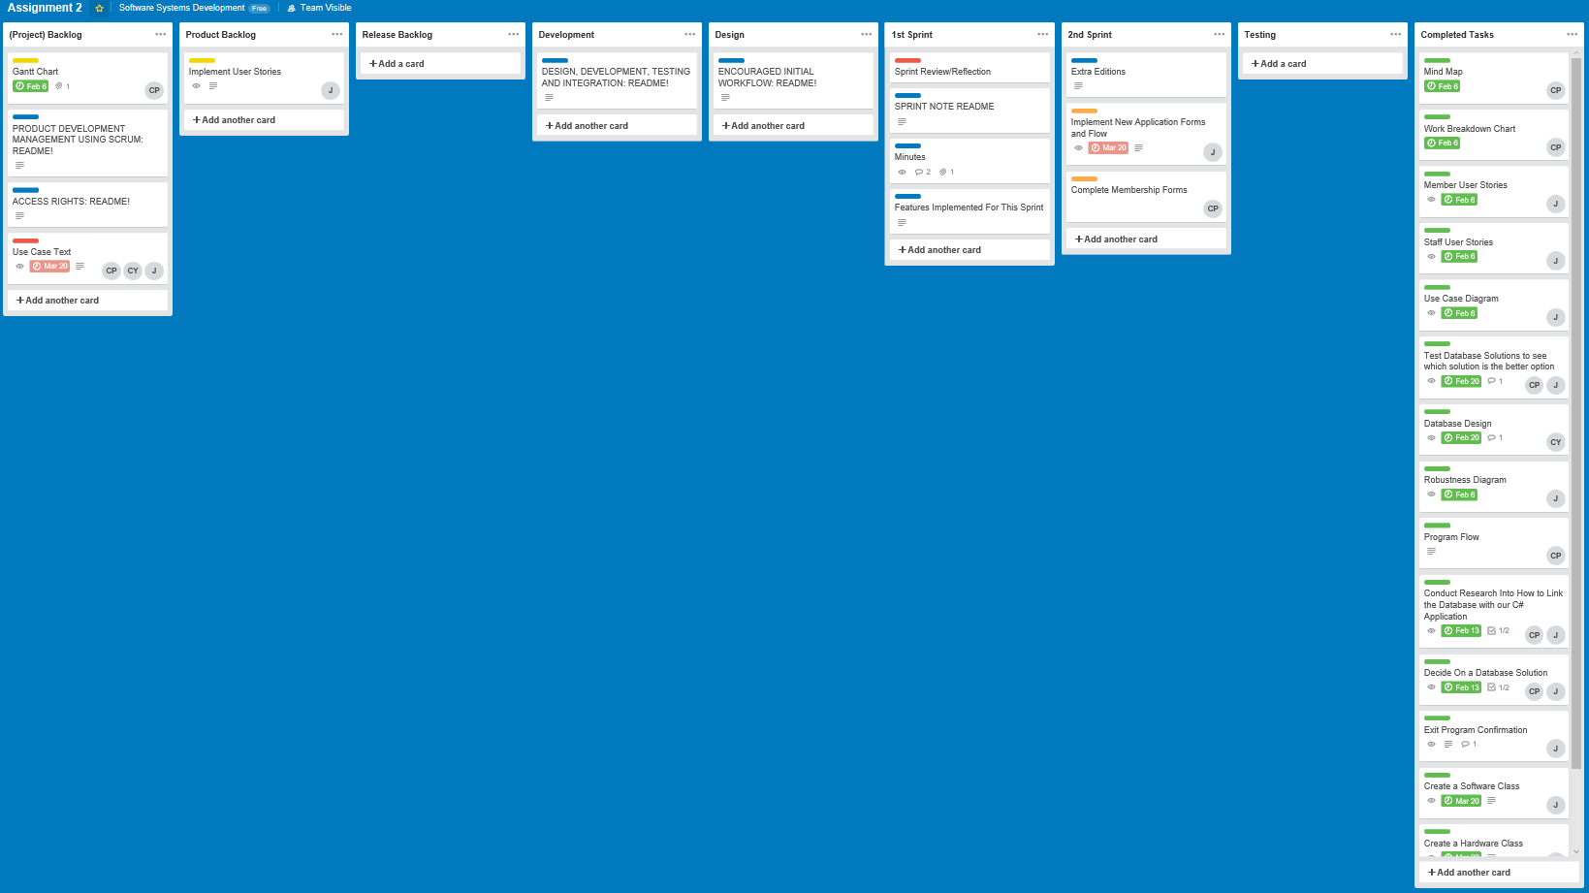

Other than this, only the Model View Controller (MVC) design pattern was used, for the implementation of the project.

Our interpretation of the SCRUM development-methodology suited our team quite well, as we were not too strict on how we obeyed it (with our team not preferring Stand-Up Meetings) and once again, there were other project deadlines that we had to consider. We still made sure to use a source-control system, update our progress in our own time-logs and note completion of tasks to the group, using the Trello board.

# Project Design

For this stage of the project, various diagrams were used to guide the design of the system.

## 5.1 Structure Chart

Starting with this diagram, for how a Game Café Staff Member adds a Database Entry:

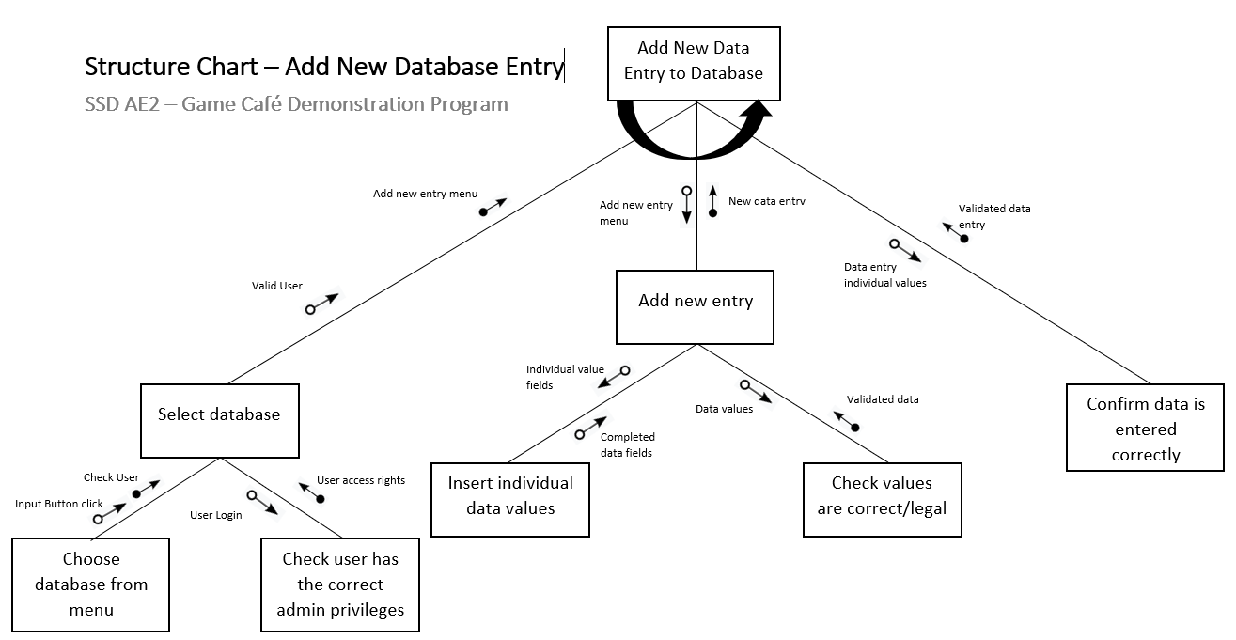

Figure 6: Structure Chart for adding new entries to the Game Cafe Database. (Chris Pryor, 2018)

## 5.2 Use-Case Diagram

This is followed by this diagram:

Figure 7: Use-Case Diagram for Game Cafe Staff Members and Members (patrons) of the Game Cafe.

From the Use-Case Diagram on the previous page, it is now possible to derive a Class Diagram, for the basic structure of the application (to perform these initial Use-Cases):

Figure 8: The Basic Class Diagram for the Game Cafe Management System (given the initial set of derived Use-Cases).

Once again, Microsoft Visio 2013 was used to create Figure 7 and 8 (but not Figure 6).

It was used as, yet again, I have experience in using Visio to form such diagrams for past projects (such as for the ESS project). With these diagrams and the layout I had created them within, clearly showing the Use Cases for the Game Café Actors and the classes involved in the implementation of the solution. The team has been fine with these means of showing these design components of the Game Café System.

# Project Development

## Logging my Tasks

To keep a log of the hours I have put into the project, I kept a project tracking log, with tasks, their descriptions, the estimated hours for that task, the hours expended, reasons for why there were less hours expended than expected (if that is the case for a particular task), any overtime hours and the reasons for why overtime hours were expended, if overtime was put in:

Figure 9: My Weekly Time-log for the project (the image flows over two pages).

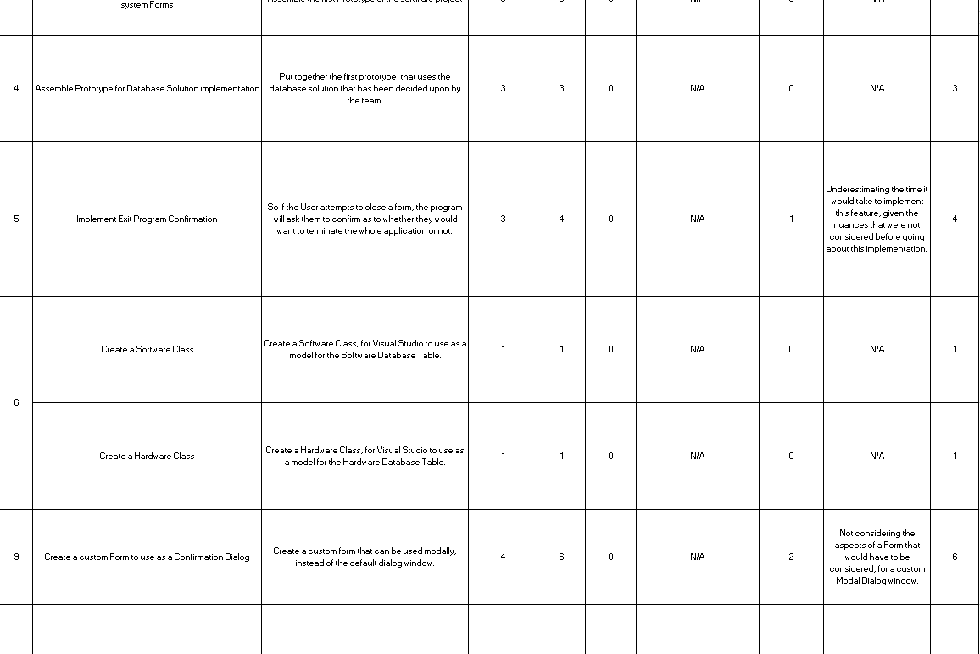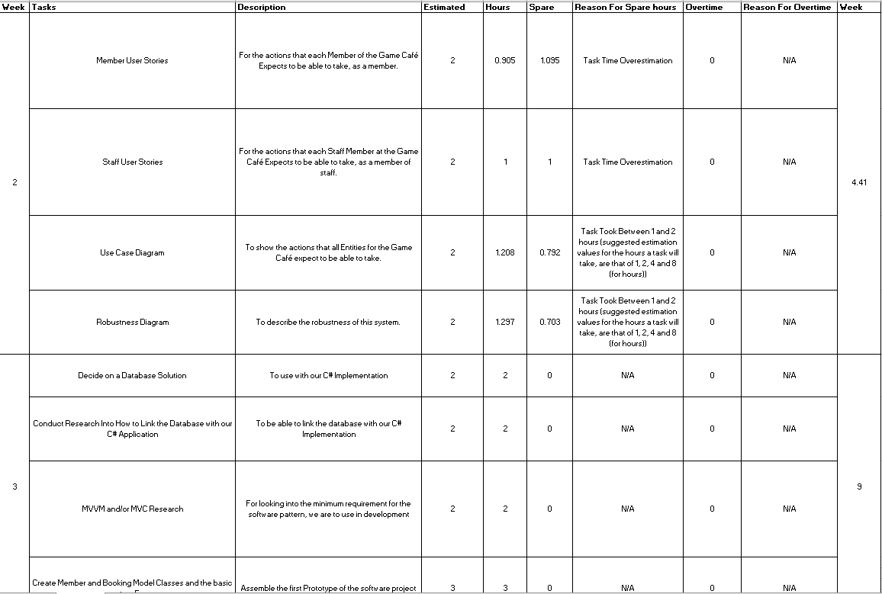

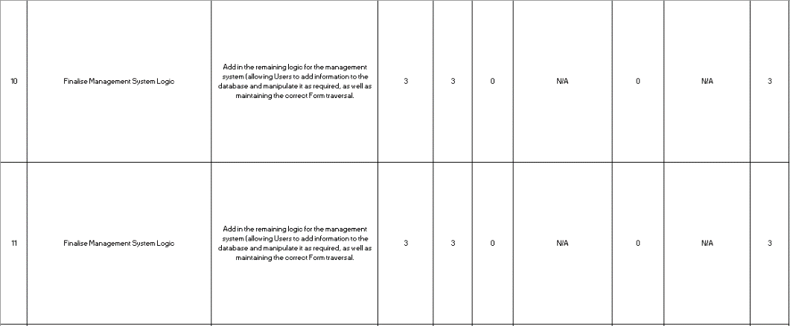

Microsoft Excel 2016 was used for this.

I used Excel, as I have used it before, for the purpose of creating hourly time-logs, for other projects (such as the ESS project), where it has been suitable for the purpose of showing my usage of time throughout those projects.

# Testing the Project

# Integrating the Project

# Refactoring for the Project

# Configuration Management/Version Control

For version control, we used a GIT repository, via GitHub:

Figure 10: The last 3 days of commits, from the 07/05/2018 to the 10/05/2018.

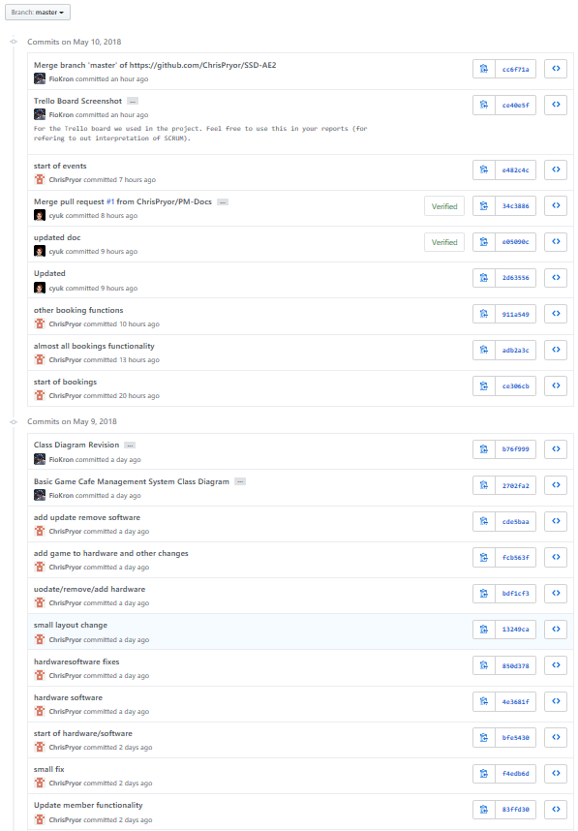

GitHub was used, as GIT is a source control system that all group members are familiar with, with me having used it for many projects and personal storage, having sufficient storage capacity for the group to use it freely and being able to see past versions of certain components of the project (whether these are code files and their revisions, or other types of files such as diagrams).

# Bibliography

MICROSOFT, © 2018a Microsoft. *Entity Framework Code First to a New Database* [Viewed on the 09/05/2018]. Available from: <https://msdn.microsoft.com/en-gb/library/jj193542(v=vs.113).aspx>

MICROSOFT, © 2018b Microsoft. *Entity Framework Code First to an Existing Database* [Viewed on the 09/05/2018]. Available from: <https://msdn.microsoft.com/en-gb/library/jj200620(v=vs.113).aspx>

# References

PRYOR C., 2018. *User Mind Map* (Unpublished). Software Systems Development

YOUD C., 2018. *Work Breakdown Structure* (Unpublished). Software Systems Development